E-news VistaArt Therapies- January 2026
VistaArt Therapies E-news January 2026 – Grants, Gatherings & Upcoming events
Hello and welcome to the first VistaArt Therapies e-news for the year 🌿
January has already been full of connection, creativity and collaborations.
- Grant from City of Unley– Free Workshops
VistaArt Therapies has received a $4,000 Community Grant from the City of Unley to run workshops for the community at the Clarence Park Community Centre. See the list of upcoming events below and attached or my website. The free workshops include i) Creativity for Wellbeing- 4-week program ii) EcoArt Therapy iii) Nature journalling iv) Vision Boards and v) Irlen Syndrome/ visual stress info session. Bookings are essential as places are limited. I am also running low-cost workshops at the Goodwood Community Centre ensuring creativity and nature connection can be accessible to all.
- Recent Workshops – Creativity in Action
It’s been wonderful to start the year with some beautiful gatherings:
• Vision Board Workshop – Yankalilla (29 January)
A session of reflection, creativity and intention-setting in a supportive group space at the fabulous Lot50 Café & Gallery.
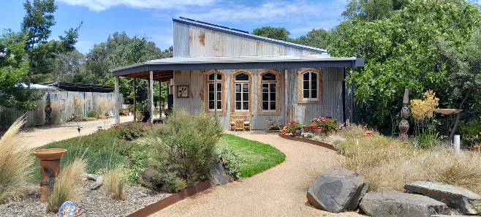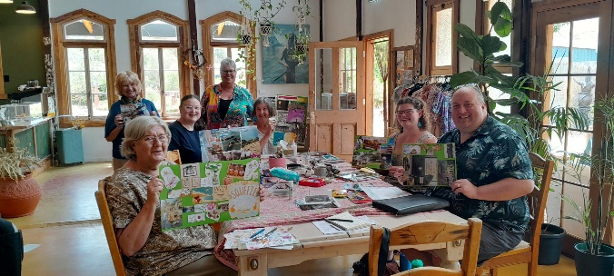
• Sip, Sketch & Bloom – Terminus Hotel Strathalbyn (1 February)
A joyful morning of nature journalling, coffee, tacos and building our own bunch of Dahlias to take home- co-facilitated with Fiona Kent and raising funds for Variety the children’s charity.
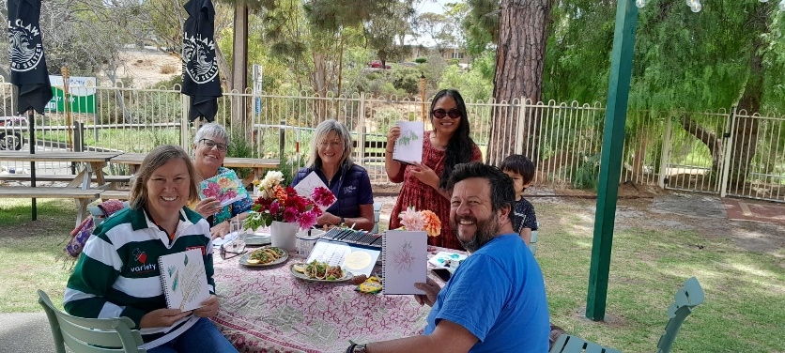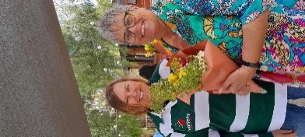
3) Collaborations I’m Loving
- Sip, Sketch & Bloom with Fiona Kent raising funds for Variety the children’s charity
- Corporate Wellbeing Workshops with Carol Buchanan, Moveon Counselling
- Essential oil roller workshops to complement our retreats with Louise Gutsche
- Pamper Fundraisers with Fiona Kent, Carol Buchanan and Louise Gutsche
- Day retreats with Dr Lesley Porter & Louise Gutsche at Sophia, Cumberland Park SA
Get in touch if you want to collaborate!

4) Upcoming Events (see attached for full list)
- Free and low cost Art Therapy & Wellbeing Workshops – Feb & March- see below and attached.
- Sip, Sketch and Bloom at the Ginny Pig Distillery 13 Feb 11am-1pm More info & bookings: here
- Women’s Retreat – Normanville 20-22 Feb – More info & bookings: here 2 places remaining!
- Pamper Fundraiser- Sophia 15 March 9:30-12:00 More info & bookings: here
- Mini-wellness retreat- WEA- 28 March 10am-4:30pm More info & bookings: here

Thank you for being part of the VistaArt Therapies community.
Warmly,
Robyn Molsher
VistaArt Therapies
Free events thanks to a City of Unley Community Grant
✂️ Vision Board Workshop
Reflect on the year that was and set intent for the months ahead with a vision board workshop. Please bring: 1-2 old magazines to cut up and scissors.
• 9 February | 10:00–12:00
• 8 March | 10:00–12:00
👉 More information and bookings here:
https://events.humanitix.com/cpcc-vision-board-workshop

🌿 Come & Try EcoArt Therapy
Explore creativity, reflection and connection to nature through guided art-making.
• Wednesday 11 February | 10:00–12:00pm
• Monday 16 March | 1:00–3:00pm
👉 More information and bookings here:
https://events.humanitix.com/come-and-try-ecoart-therapy-for-adults

🎨 Creativity for Wellbeing (4-week program)
Four weekly sessions using art therapy processes to enhance wellbeing, self-expression and reflection.
📅 Tuesdays | 4 March – 25 March
🕙 10:00–12:00
👉 More information and bookings here:
https://events.humanitix.com/creativity-for-wellbeing

👁️ Seeing Differently – Understanding Visual Stress
Learn about visual stress, Irlen Syndrome, signs to look for, and how coloured overlays can help.
• 11 March | 3:30–4:30pm
👉 More information and bookings here:
https://events.humanitix.com/seeing-differently-understanding-visual-stress

📓 Come & Try Nature Journalling
A relaxed introduction to nature journalling combining observation, creativity and mindfulness.
• 14 March | 10:00–11:30am
• 18 April | 10:00–11:30am
👉 More information and bookings here:
https://events.humanitix.com/come-and-try-nature-journalling

📍 Location: Clarence Park Community Centre
🎟️ Cost: Free (bookings essential)
🎨 Some materials provided- see the “to bring” section of each event.

